Abstract
Preparing icccbe paper (replace with own title- max two lines)
A Author & B Another
University of Tingham, UK
T Other
Worldwide Computing 4 Construction, UK

These instructions are intended to guide authors when preparing papers for the International Conference on Computing and Civil Engineering – 2010. Authors are requested to strictly adhere to the format specified in this template including the page size and margins. The best results are achieved if authors would overwrite the texts in this template file with their own. Any text copied from other documents must be pasted as “unformatted text” using the “Paste Special” menu command. Paper lengths should not exceed 6 pages. Exceptions for longer papers could be granted by contacting the conference chair. The paper title and all headings are only first letter capitalised. The abstract should have a maximum length of 300 words. The abstract is in 11 pt Times New Roman with 13 pt leading and the heading is size 14 with 16 points leading.
Keywords: Maximum of five keywords, separated with commas

Type fonts
This paper template uses the Times New Roman font throughout. Body text is size 11 with 13 pt leading and justified. The first paragraph following a heading is set as left justified with no first line indent (the same as this paragraph). The format is automatically set when pressing Enter after a heading. The format is also achieved by selecting the text and applying the style “First paragraph”.
Second and subsequent paragraphs are indented 5 mm from the left-hand margin, with no extra lines between the paragraphs. The format is automatically set when pressing Enter after a “First paragraph” style. The format is also achieved by selecting the text and applying the style “Normal”.
Emphasized words in running text should use italic. Bold or underlined texts should never be used. The only exception for using bold is when denoting vectors. Special characters should use the Symbol or Arial Unicode fonts.

Headings
Headings are automatically numbered when the appropriate style is applied. All headings have only the first letter capitalised. Heading is automatically numbered and indented by 0.5mm from the left when the appropriate style is applied. The first order heading uses the style “Heading 1”. The second order heading uses the style “Heading 2” and so on. To achieve the correct style either select the appropriate style and then write the text or highlight existing text and then apply the required style.
First order heading are 14 point Times New Roman, beginning at the left-hand margin (the same as the heading of this section). They use consecutive whole numbers with no full stops.

Second order headings
Second order headings are in italic 12 point Times New Roman, beginning at the left-hand margin. They are consecutively (and automatically) numbered after the preceding first order heading.

Third order headings
These headings are typeset in 11 pt Times New Roman, beginning at the left-hand margin. They are consecutively (and automatically) numbered after the preceding second order heading. It is advisable to use this level of heading very sparingly.

Figures
Figures must use the style "Picture". Ensure the quality of graphics is sufficiently high for readability and for black and while (gray scale) printing. Each figure is numbered and inserted in the text after the first reference to it. Number the figures consecutively (e.g. Figure 1). Figure parts should be denoted by lowercase letters (a, b, c, etc.). Figure captions are in 10 pt Times New Roman, 11 pt leading and use the style "Caption". Captions have the format: figure number, figure caption text.
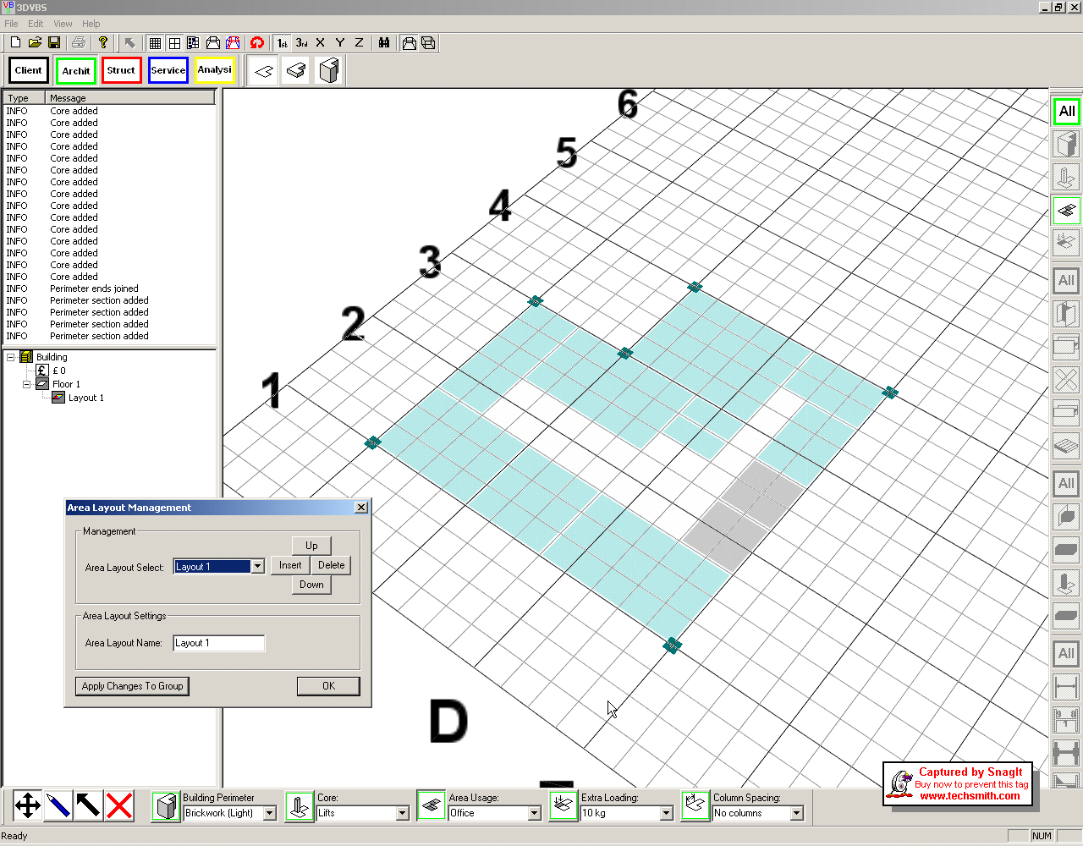Figure 1, Definition of floor plan and usage - using the style "Caption"

Tables
Tables are placed close to the first time they are referred to in the text. Tables should be left justified and use as simple a format a possible. The table caption and footnote use style "Table caption" which is size 10 points leading with 11 points leading left justified to the margin. Place the caption above the table.

Table 1. Results of concrete compressive - using the style "Table Caption"
Sample reference* | Age  (days) | Density  (kg/m3) | Strength  (N/mm2)
AM1 | 7 | 2417 | 36.5
AM2 | 7 | 2370 | 37.0
AM3 | 20 | 2362 | 43.5
AM5 | 23 | 2429 | 45.0
* All samples used limestone aggregate.

Citations and bullet points

Citations
Citations within the text are in the Harvard style in the way of author name/s and year of publication in parentheses as follows:
- one author: (Tizani, 2007)
- two authors: (Hussein and Hunt, 2009)
- three authors and more (Mawdesley et al., 2004)
- more than one reference (Smith 1998; Wang 2007), place a semicolon in between the references

Bullet points
Bullet points should use the “Bullets” style as illustrated above. Similar to other styles this can be achieved by selecting the required text and applying the style “Bullets”. First paragraph style text should follow the last bullet point. Bullet points use 11 points New Times Roman with 13 points leading and 5mm hanging indentation.

Equations
Equations are left justified and indented by 10mm from the margin with a space before and after and equation number at right-hand margin (See Eq. 1). The format can be achieved by applying the style "Equation". MathType or the Microsoft equation editor can be used and the resulting graphics inserted into the text at the required indentation. Use abbreviation Eq. and Eqs. (e.g. Eq.1) to cite equation/s in the text. Number the equations consecutively and place the number as shown below.
2xy + 2Ax + 2Bxy = Z (1)

Acknowledgements
This section uses the heading style "Heading no number" and the standard first paragraph text.

References
References are in 9 pt, 10 pt leading, unnumbered and in alphabetical order. The required format can be achieved by applying the style "References" and then formatting the primary publication title in italics. Authors' names and initials must be in CAPITALS. The second and subsequent lines are indented by 5mm. Below are examples of references to: a journal paper, a conference contribution, a book, a chapter in a book and an online publication.

HUSSEIN, M.F.M. and HUNT, H.E.M., 2009. A numerical model for calculating vibration due to a harmonic moving load on a floating-slab tracks with discontinuous slabs in an underground railway tunnel. Journal of Sound and Vibration, 321(1-2), 363-374.
MAWDESLEY, M.J., LONG, G. and AL-JIBOURI, S., 2004. Simulation and games to improve construction productivity. In: Interbuild 11th International Conference, 2004, Cairo, Egypt.
SMITH, I., 1998. Artificial Intelligence in Structural Engineering, Information Technology for Design, Collaboration, Maintenance, and Monitoring. London: Springer-Verlag.
TIZANI, W., 2007. Engineering design. In: AOUAD, G., LEE, A., WU, S., eds. Constructing the future: nD modelling. London: Taylor & Francis, pp. 14-39
WANG, X., 2007. Mixed Reality in the Classroom, Available online: www.arch.usyd.edu.au/~xiangyu/mixed_reality.html, Last accessed: August 2007.

